COMPUTER NETWORKS LAB
ASSIGNMENT 2

MU IN NASIF
BCSE-III, semester 5
001910501036

Topic: Implementing Data Link Layer protocols

Overview

We implement the three data link layer protocols for flow control,
- Stop and Wait
- Go Back N Sliding window
- Selective Repeat Sliding Window

Constrains

Sender, Receiver and Channel all are independent process. There may be multiple Transmitter and Receiver process. The channel process introduces a random delay and/ bit error while transferring frames.

Specifications

- Language used: JAVA ( compiler: javac 17, runtime env: 17+35-LTS-2724 )
- Frame format used: IEEE802.3

|SFD: Start frame delimiter flag ( 10101011 ) |

|------------------------------------------------------------|
| Preamble | SFD | Destination address | Source address | Length, type | Data + Padding | CRC
| 7bytes |1byte| 6 bytes | 6 bytes | 2 bytes | | 4 bytes

|maximum and minimum lengths|
|----------------------------------------------------------------------------|
| Destination address | Source address | length PDU | Data and Padding | CRC |
| 6 bytes | 6 bytes | 2 bytes | | 4 bytes |

|---minimum.len: 46 bytes--|
|--maximum.len: 1500 bytes-|

|--------------------------- Minimum frame length: 64 bytes -----------------------|
|-------------------------- Maximum frame length: 1518 bytes ----------------------|

- External Library used: socket.io

Code

The program is set in independent packages. The connection is created in the channel using the external library: socket.io the channel introduces a random delay and random error in the sender side at random intervals. A sender control and a receiver control module controls the data flow in the system a Helper package contains all the utility methods essential for the frame manipulation

`Flow diagram of the code

Sender
control
Send
packages
Receives
Packages

Frame
Creation
Timer
control

Channel
Insert delay
Insert error

Frame
Validation

Receiver
control
Receives
Insert delay
Acknowledgement
Generation

Sender side Statistics

Time taken to send 50 frames

Process | Time taken (in minutes)
Stop and Wait | 0.7
Go Back N | 1.8
Selective Repeat | 2.11

Average roundtrip

Program output overview

Stop and Wait

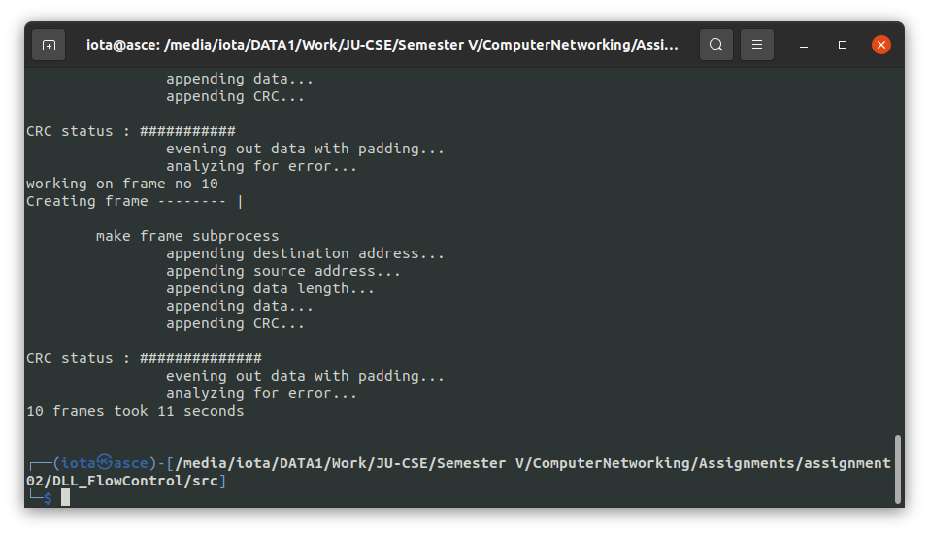

Go Back N

N = 4

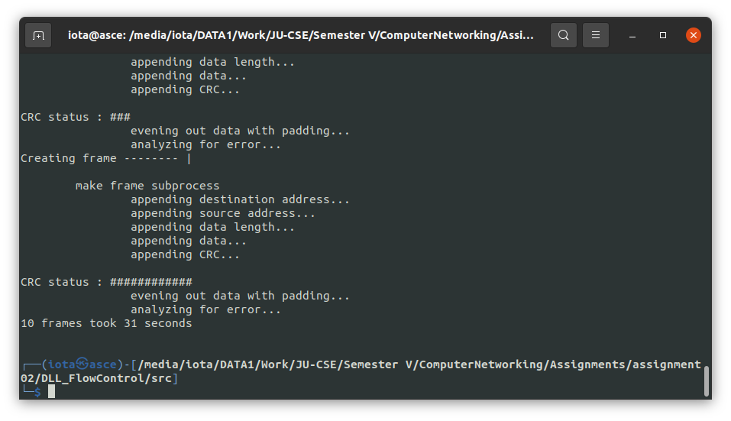
Selective Repeat

